Calamity Day Makeup #1
English 11

State Common Core Standards

Procedures:
- Using the Internet, find an article, interview, or commentary on a piece we are currently reading or have read in the past. For instance, if you searched “Langston Hughes Interview,” you’d find that there are a few recorded interviews with him. You would also find the following articles on The New York Times Web site:

Returning All the Works of Langston Hughes to Print
By JO THOMAS
The University of Missouri Press is placing a claim on its native son by publishing for the first time the complete ''Collected Works of Langston Hughes'' in 18 volumes. The first three volumes were published in June. The entire set will be available in time for the centenary of his birth, Feb. 1, 2002.
July 31, 2001ARTSNEWS

Advice With Avocados: A Letter-Writing Friendship
By JANET MASLIN
Langston Hughes was 22 and Carl Van Vechten 44 when they met at a benefit party in Harlem and their unlikely friendship began.
March 5, 2001ARTSREVIEW

Child's Tale About Race Has a Tale Of Its Own
By DINITIA SMITH
In December 1934, the poet Langston Hughes went to Mexico City to wrap up the business affairs of his late father, James, only to discover that he had been disinherited. Father and son had had a difficult relationship.
November 26, 1997ARTSNEWS

Good Race Men
By DAVID HERBERT DONALD
Best known for his poetry, Langston Hughes (1902-67) was also the author of two novels, five plays, several children's books, two autobiographies and a great deal of short fiction.
September 1, 1996ARTSREVIEW

He Heard America Jiving
By HENRY TAYLOR
Langston Hughes' poems moved to blues and jazz rhythms, with which he experimented more rewardingly than any other important poet of this century.
December 25, 1994ARTSREVIEW

Langston Hughes On the IRT; A Poem Arouses Many Feelings
By JOE SEXTON
The Transit Authority's program is called Poetry in Motion, and on this particular morning eight lines of Langston Hughes rumble along the length of the IRT No. 3 line.
- You may also search for articles or interviews concerning the following:
  - Billy Collins
  - Langston Hughes
  - The Slave Trade (The Middle Passage)
  - Arthur Hailey and Roots
  - Arthur Miller
  - The Crucible
  - The Salem Witch Trials
  - Cory Doctorow
  - Little Brother
- Listen to or read the piece you found and then complete the following:
  - Summarize the piece in a paragraph or two. Be as detailed as possible.
  - Write a review of the piece. This is essentially your personal reaction to it. Did you like it or not? Why? Did you learn something new? If so, what? Was it well-written? Interesting? Did you disagree with it?
  - Explain in a few sentences what the connection is to the piece we read.
- Turn in your written assignment when it’s due.

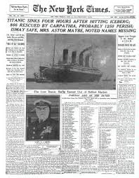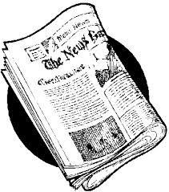

P.S. You can also use any of the articles mentioned in this document.

