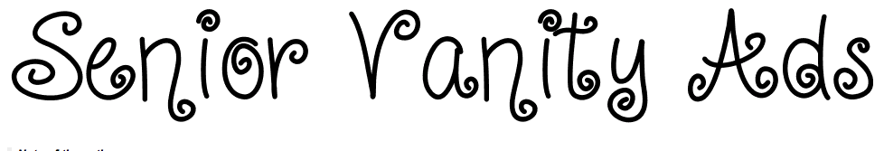

Dear Parents of 2016 Seniors:

The Coventry High School yearbook staff is selling advertisement space to parents and guardians who would like to honor their 2015 senior graduate. The process is quite simple…

Go to www.yearbookordercenter.com/index.cfm/job/40261

The website provides you with step-by-step instructions on how to create an ad and upload pictures of your favorite senior.
If you prefer to pay with cash or check, please complete the order form on the reverse side. Don't forget to include a photograph with your student's first and last name.

Pricing:
$25.00 for 1/16th (business card size)
$45.00 for ½ page
$80.00 for full page

Sample:

If you have any questions regarding vanity advertisements, please contact Ms. Janice Nadeau at 330-644-3004 or at jnadeau@coventryschools.org.
Congratulations Matt!
We are so proud of you!

Love,
Mom, Dad,
Zach, & Nick

