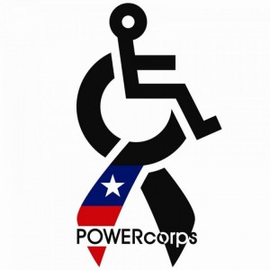
Unskating Party
Roller Skating Fun for Children with Disabilities!

Wheelchairs, Walkers, Crutches, Canes and
Shoes permitted on the rink.

NO FEE, Free Skate rental, Refreshments provided

Wednesday, April 26th, 2017
6:00pm - 8:00pm
Springfield Lake Roller Rink
Port – Summit Rotary
1220 Main St. Lakemore, OH 44250

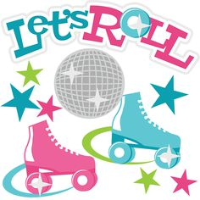
Contacts:
Sandy Craft: scraft@sepirates.org
Robin Howard: rhowardpm@aol.com
Kelly Butler: kelly.butler@esc-cc.org

Directions: Rt224 to Canton Rd / Rt 91 south, go ¼Mile,
Turn right on Springfield Lake Dr., follow road to rink.

